**Topic:** The Great Theorem, Divergence of the Harmonic Series

**Notes on Topic:**

**The Great Theorem, The Divergence of the Harmonic Series**

This proof was concocted by Johann but appears in Jakobs *Tractatus de seriebus infinitis,* but Jakob gave proper credit to his brother

Johann had to show the harmonic series diverges to infinity, and he rested his argument on the argument of Leibniz with his convergent series we examined earlier

Peculiar that the “well-behaved” convergent series sheds light on the bizarre harmonic series

**Theorem:** The Harmonic Series $1+\frac{1}{2}+\frac{1}{3}+\frac{1}{4}+...+\frac{1}{k}+...$ is infinite.

**Proof:** Introduce $A=\frac{1}{2}+\frac{1}{3}+\frac{1}{4}+...$ which is just the series minus the first term.

He then transformed the series into one whose numerators are 1, 2, 3, 4, 5, … so A becomes,

$A=\frac{1}{2}+\frac{2}{6}+\frac{3}{12}+\frac{4}{20}+....$

He then designated the series C which is the series Leibniz had examined, then he created successive series that subtracted $\frac{1}{2}$, $\frac{1}{6}$, $\frac{1}{12}$, $\frac{1}{20}$,

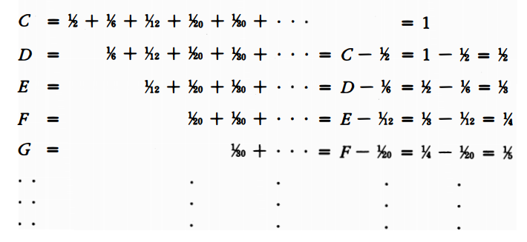

He then added up the two leftmost columns to get,

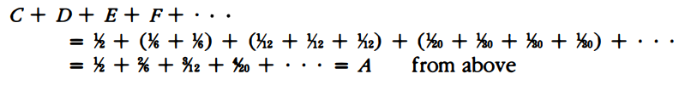

Then when summing the leftmost and rightmost columns we get,



Johann then concluded that because the sum of the series equals both A and 1+A, then he concluded that A = 1 + A, he put it “the whole equals the part” . No finite quantity could be equal to one more than itself, thus he concluded that A must be an infinite quantity. Since 1+A was the sum of the harmonic series, than his argument was finished.

**Q.E.D.**

**Some analysis and criticism**

His method of showing divergence differs greatly from today’s method

Today one would take any large quantity N (no matter how large) and show the series exceeds N, then since the series surpasses any whole number, it must diverge to infinity

Jakob observed, “The sum of an infinite series whose final term vanishes perhaps is finite, perhaps infinite.”

Although this wording makes a modern student cringe using the phrase “final term” of a series, but Jakob is commenting on the earlier conjecture, even if the individual terms of the series approach zero, that does not guarantee the series itself converges.

Jakob, perhaps due to the unexpectedness of this result pens,

*As the finite encloses an infinite series*

*And in the unlimited limits appear*

*So the soul of immensity dwells minutia*

*And in narrowest limits no limits inhere*

*What joy to discern the minute to infinity!*

*The vast to perceive in the small, what divinity!*

**Additional Suggested Reading**: None

**Assignment:** Homework 7 Problem 104, 105